**ASSIGNMENT3**

# Create a Bucket in IBM object storage.

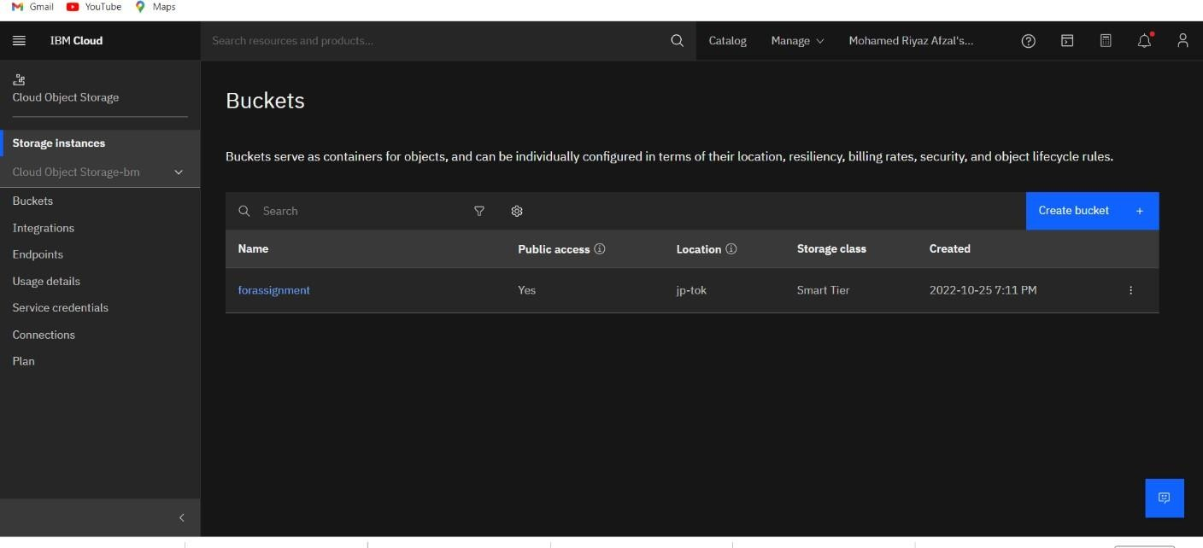

1. Upload an 5 images to ibm object storage and make it public. write html code to displaying all the 5 images.

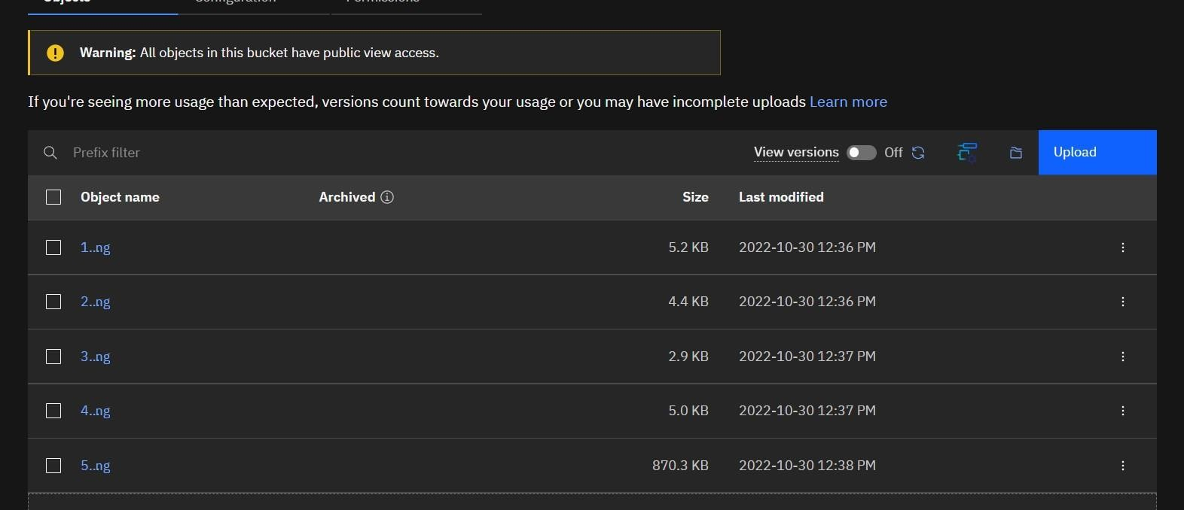

HTML Code to display the images in IBM Object Storage.

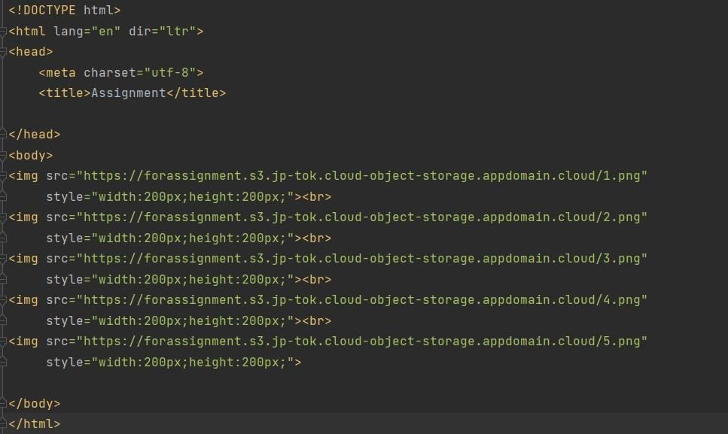

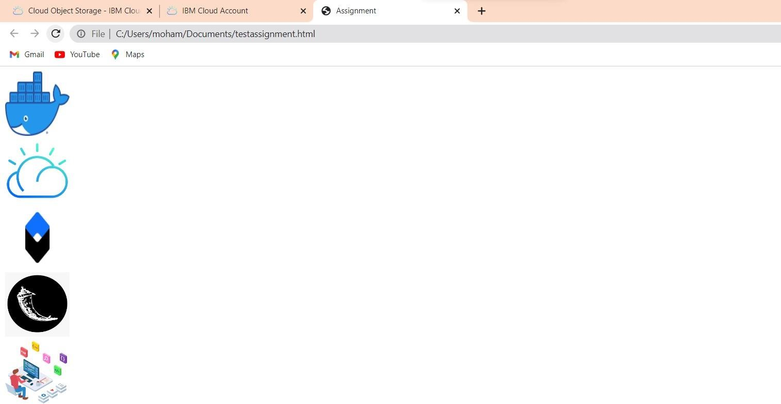OUTPUT

# Upload a css page to the object storage and use the same page in your HTML code.

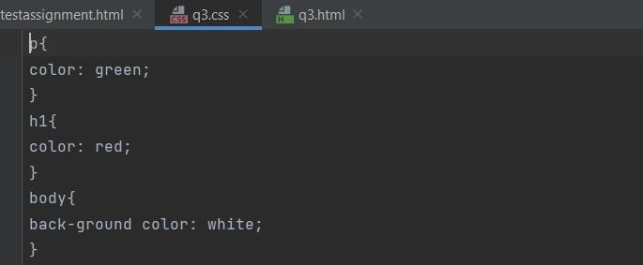

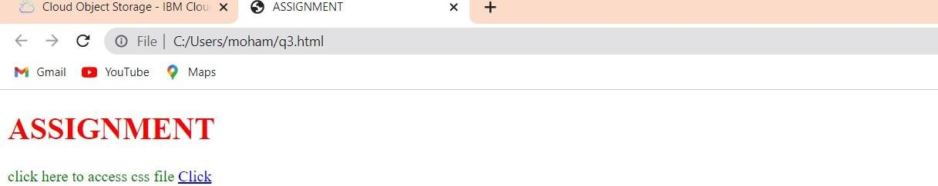

1. Design a chatbot using IBM Watson assistant for hospital. Ex: User comes with query to know the branches for that hospital in your city. Submit the web URL of that chat bot as a assignment

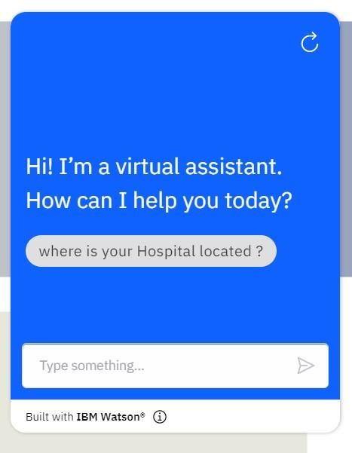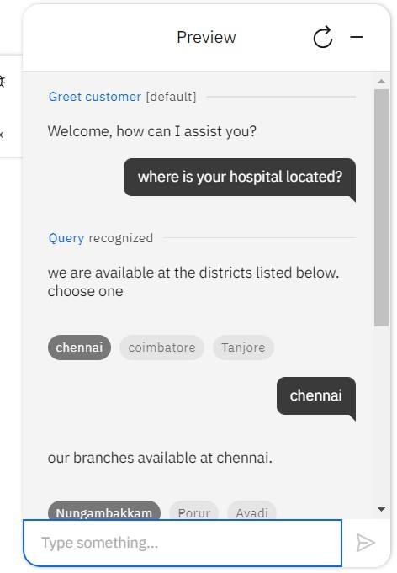

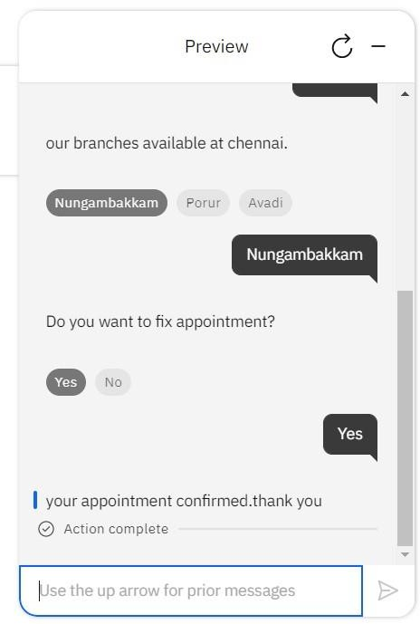

# Create Watson assistant service with 10 steps and use 3 conditions in it. Load that script in HTML page

